### Figure 1

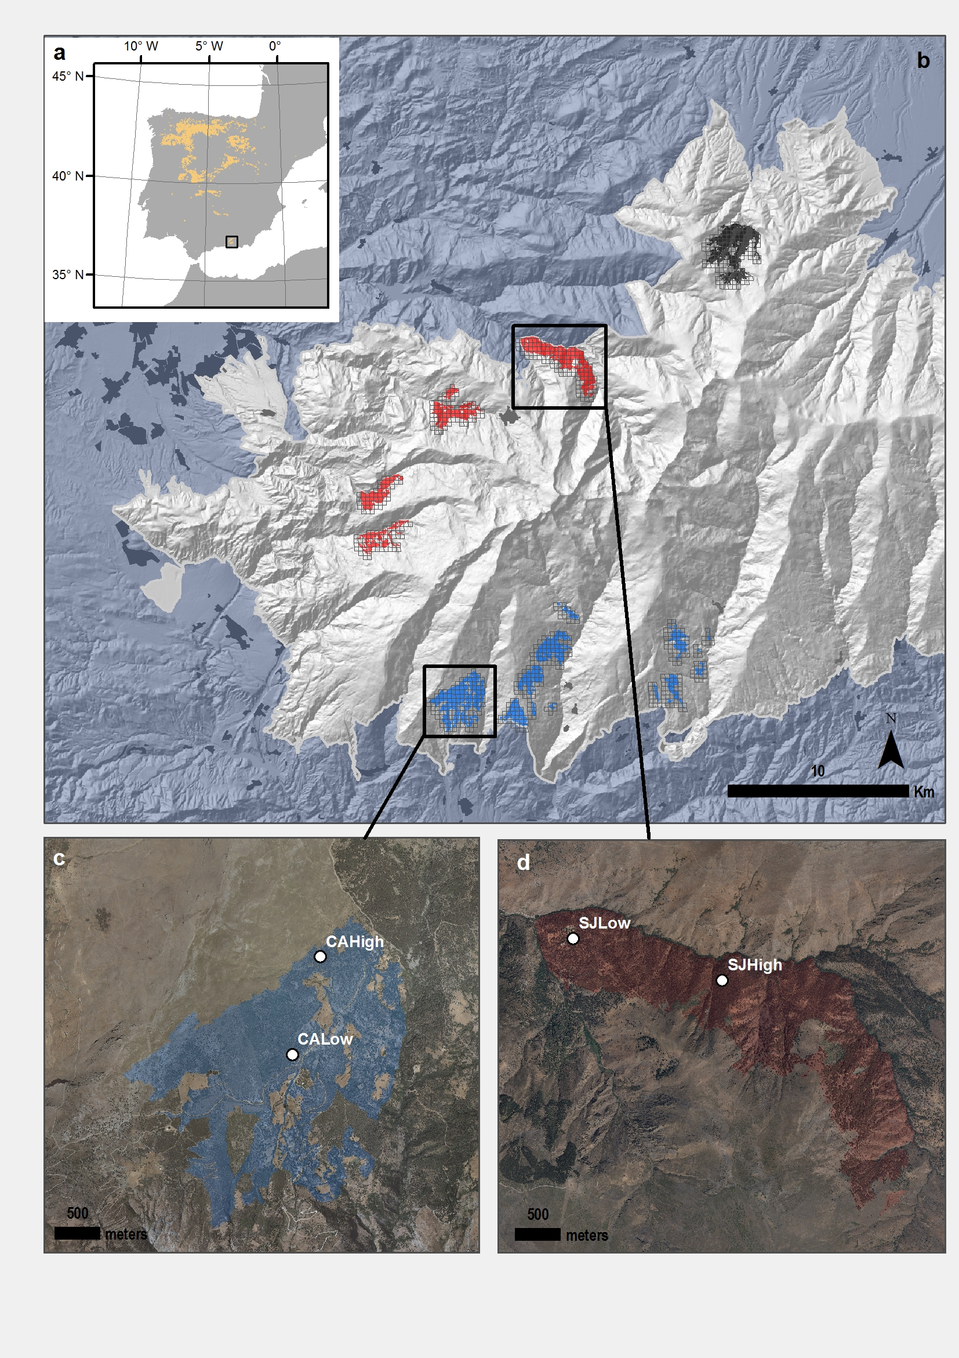

**Figure 1**. Distribution of *Quercus pyrenaica* forests in Iberian Peninsula (a) and in Sierra Nevada mountain range, where three cluster of oak populations have been identified (Pérez-Luque et al. 2015) (showed in different colour) (b). A grid of with the MODIS pixels for each population is shown (see material and methods). Detailed location of the sampling sites: northern (San Juan, SJ) (c) and southern ones (Cáñar: CALow and CAHigh)(d). Colour Orthophotography of 2009 from Regional Ministry of the Environment, Regional Government of Andalusia.

### Figure 2

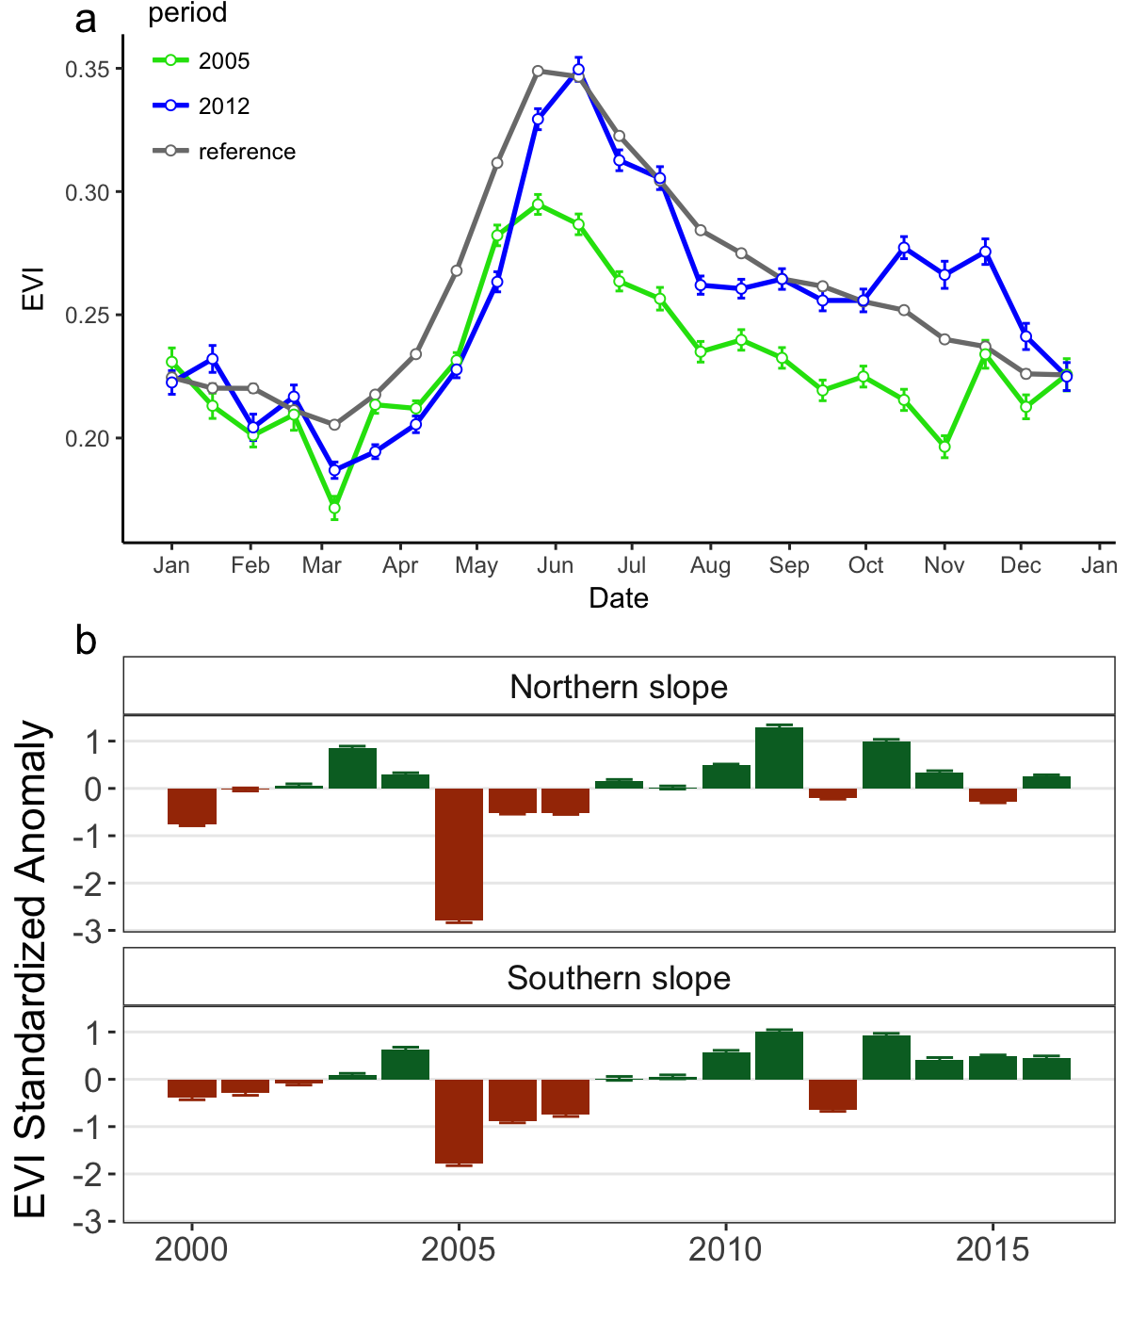

**Figure 2.** Comparison of EVI profile for the reference period (*gray*) and during the 2005 (*green*) and 2012 (*blue*) drought events (a). EVI standardized anomaly ($EVI sa$) during the period 2000-2016 for northern and southern populations (b). Error bars show standard error.

### Figure 3

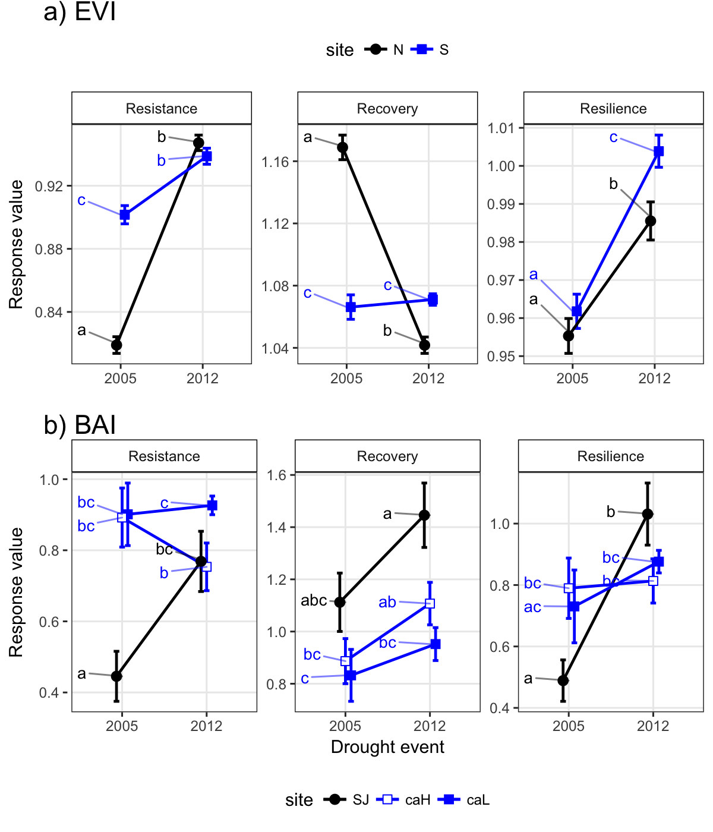

**Figure 3.** Response of northern (*black*) and southern (*blue*) populations of *Q. pyrenaica* forests to drought in terms of resistance, recovery and resilience of greenness (EVI; a) and tree growth (BAI; b) for the years 2005 and 2012. Different letters above bars indicate significant post hoc differences between groups (see material and methods).

### Figure 4

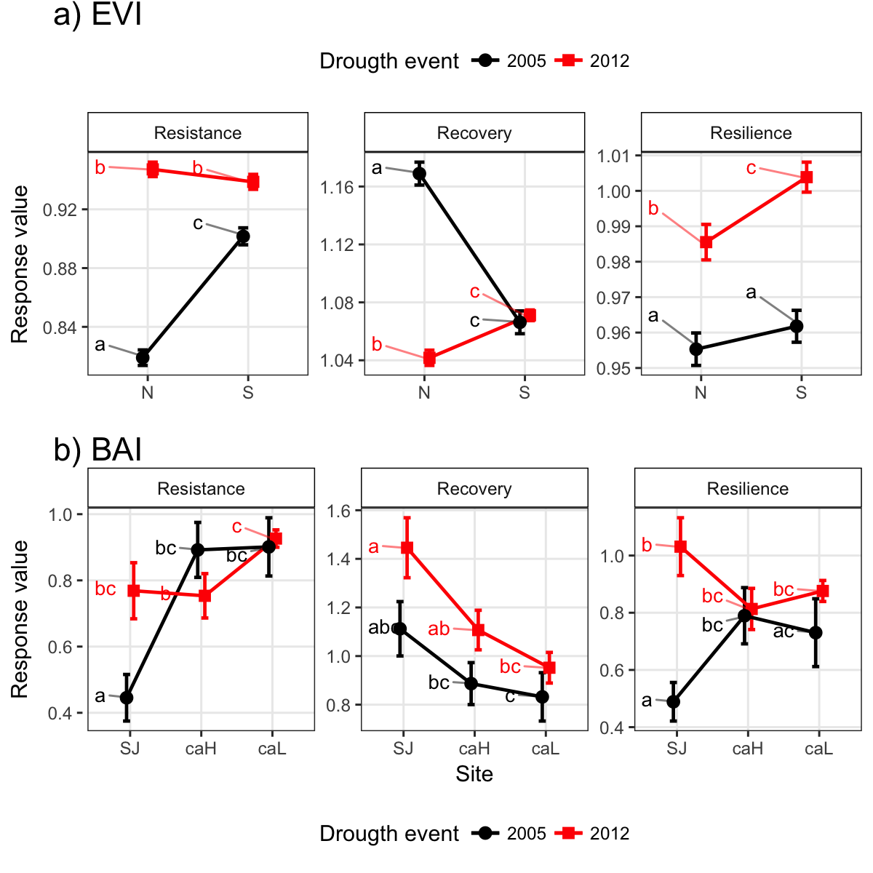

**Figure 4.** Response of *Q. pyrenaica* forests to 2005 (*black*) and 2012 (*red*) drought events in terms of resistance, recovery and resilience of greenness (EVI; a) and tree growth (BAI; b) by site. Different letters above bars indicate significant post hoc differences between groups (see material and methods).

### Figure 5

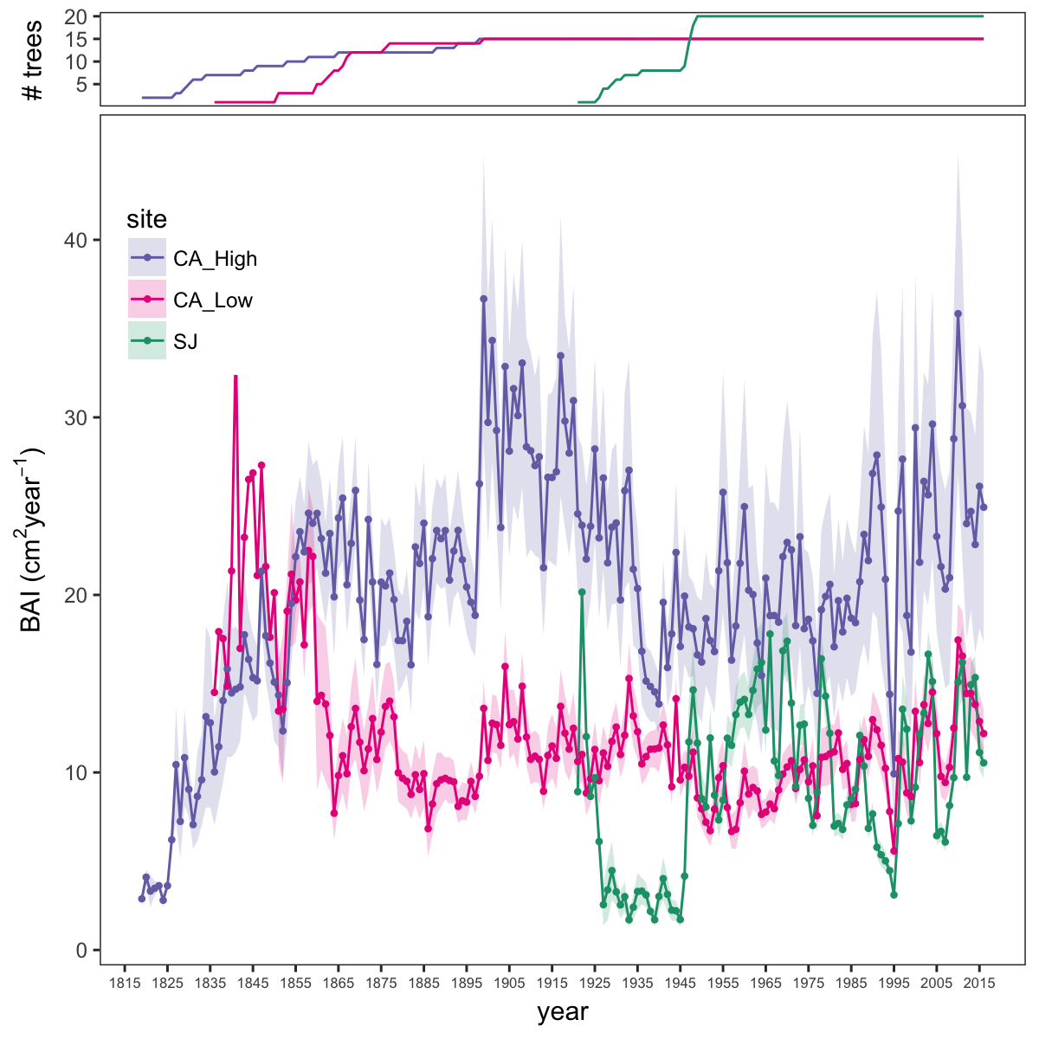

**Figure 5.** Basal Area Increment (BAI) chronologies of *Q. pyrenaica* for northern population (SJ; *green*) and southern ones: low-elevation (CA_Low; *pink*) and high-elevation (CA_High, *purple*) sites. Shading areas coorespond to standard error of the mean. Number of series are displayed in the upper plot.

# Figure 6

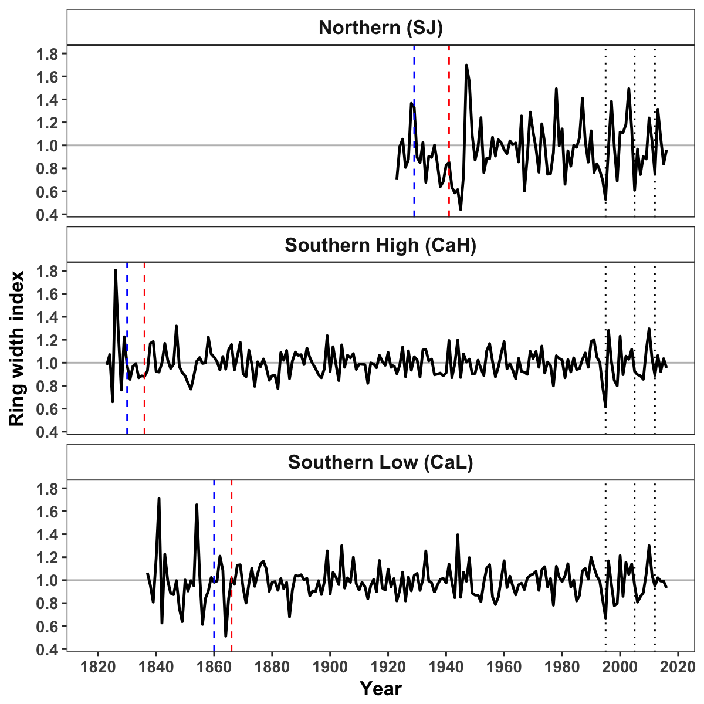

**Figure 6.** Residual Tree-ring chronologies obtained for the *Q. pyrenaica* sites. Dashed red lines indicate the start of the reliable period (EPS > 0.85). Dotted black lines showing the three most recent severe drought years (1995, 2005 and 2012).

# Figure 7

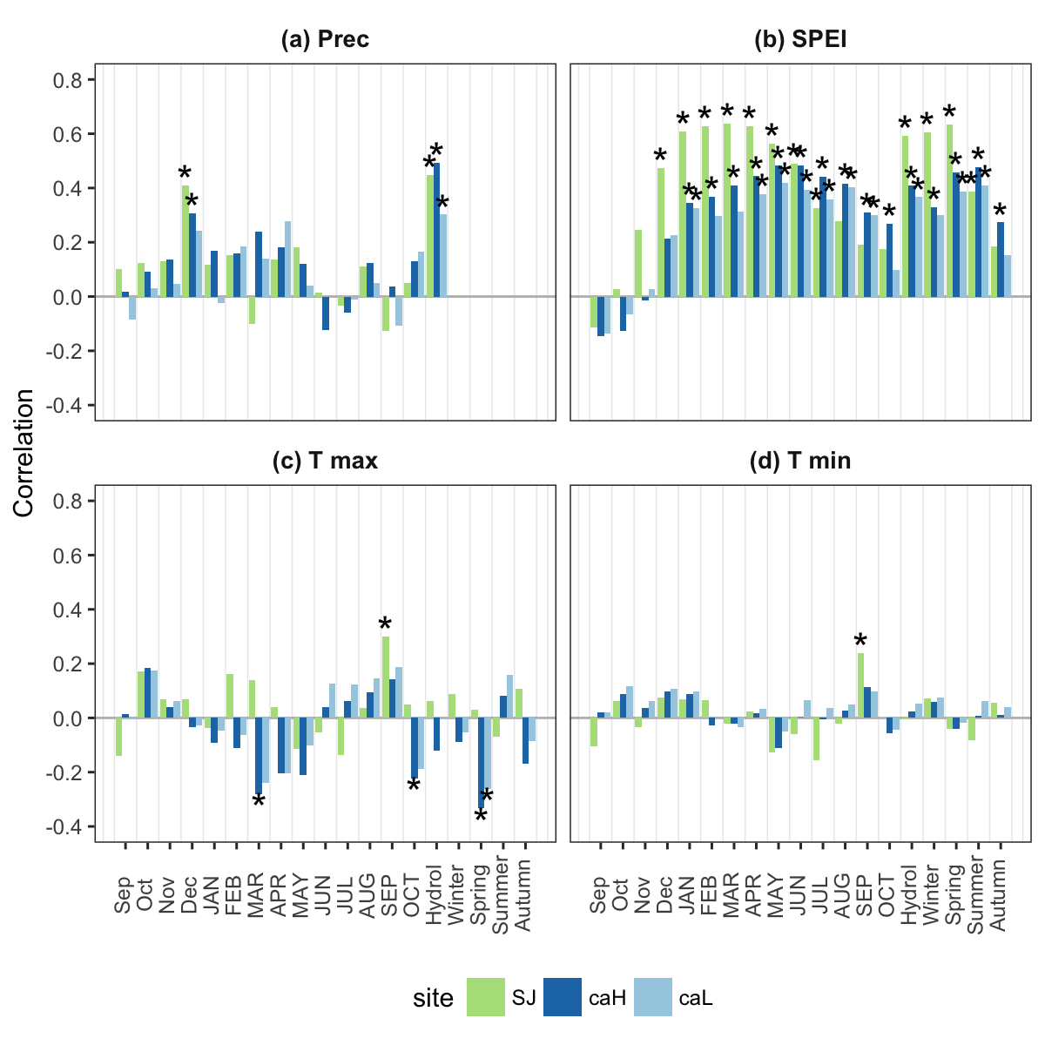

**Figure 7.** Correlation coefficients obtained by relating tree-ring residual chronologies (RWI) of *Q. pyrenaica* and monthly climatic data (precipitation (a), SPEI (b), maximun (c) and minimun (d) temperatures) for northern site (*green* bars), low-elevation southern site (*light blue* bars) and high-elevation shouthern (*dark blue* bars) site. Asteriks indicate significant ($P<0.05$) correlation coefficients.

# Figure 8

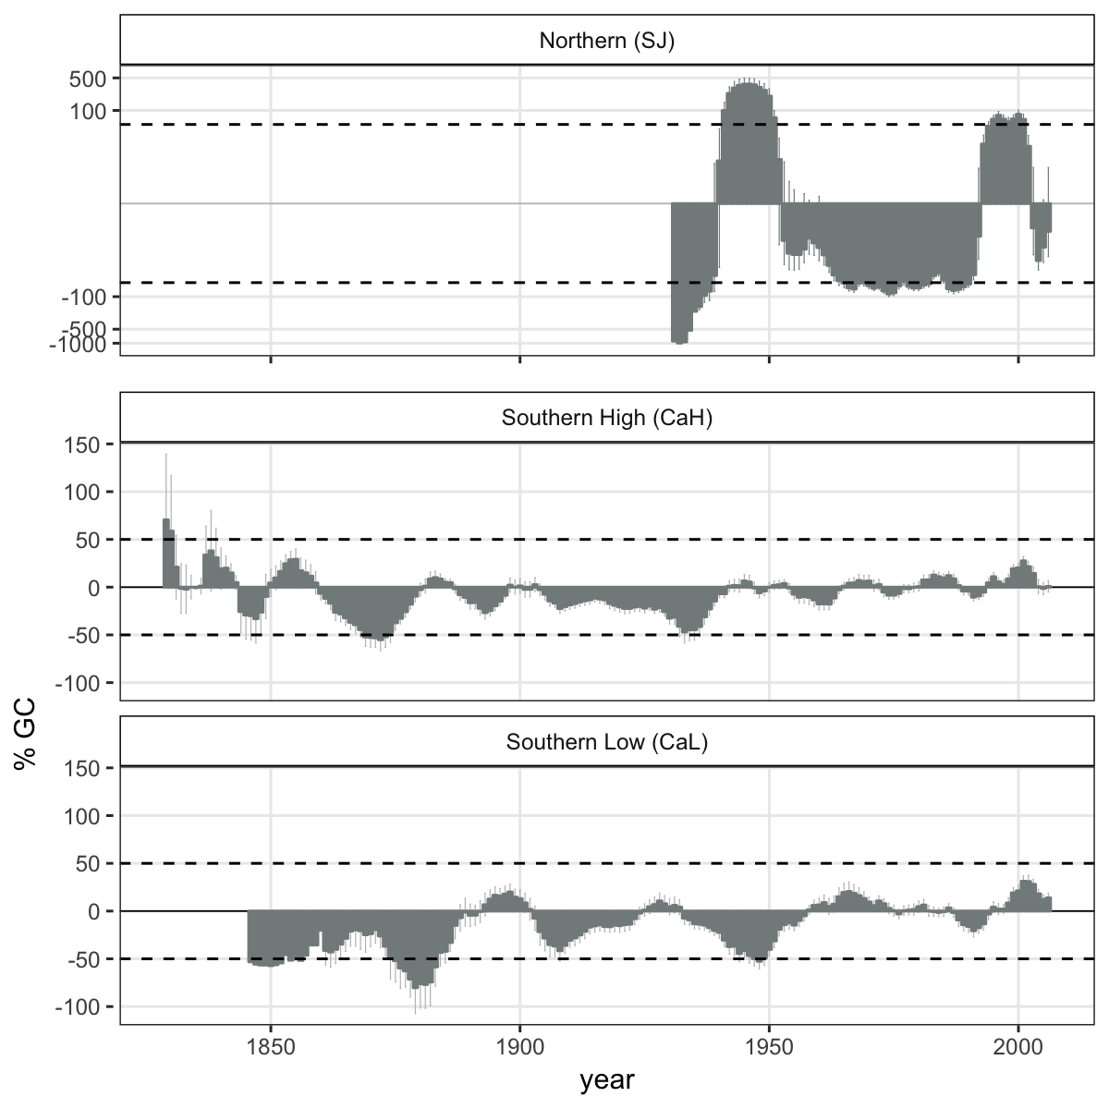

**Figure 8.** Comparison of median growth change ($GC$) following (Nowacki and Abrams 1997) for *Q. pyrenaica* sites. Dashed black lines indicate a threshold of 50 % of GC (see material and methods).

# Figure 9

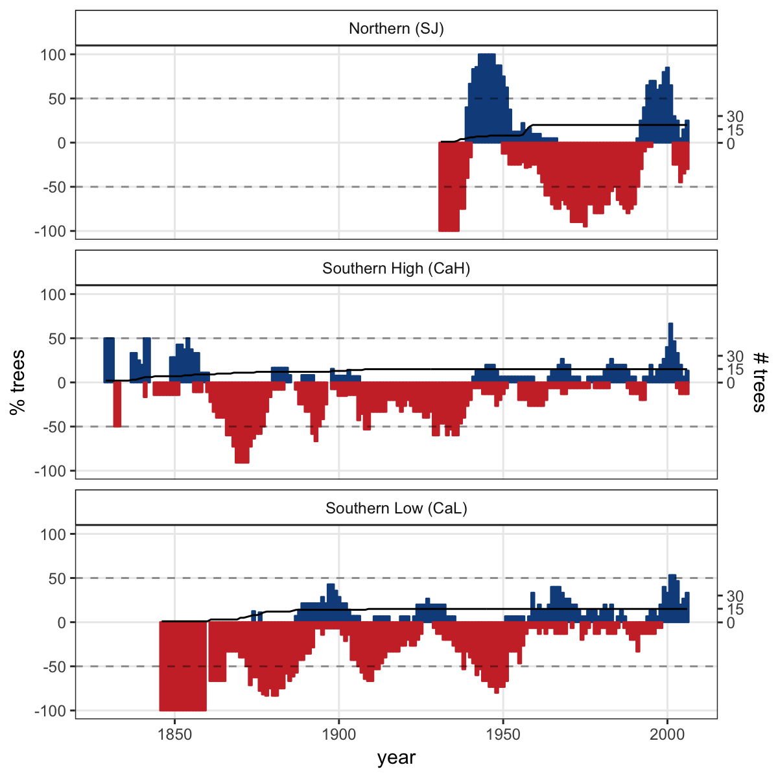

**Figure 9**. Percentage of *Q. pyrenaica* trees affected by GC > 25 % by site. *Black* line shows number of trees (rigth-axis).

Nowacki, G. J., and M. D. Abrams. 1997. Radial-growth averaging criteria for reconstructing disturbance histories from presettlement-origing oaks. Ecological Monographs 67:225–249.

Pérez-Luque, A. J., R. Zamora, F. J. Bonet, and R. Pérez-Pérez. 2015. Dataset of migrame project (global change, altitudinal range shift and colonization of degraded habitats in mediterranean mountains). PhytoKeys 56:61–81.